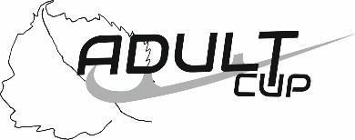
Music Form
Mariánské Lázně, Czech Republic
April 10th – 12th, 2026

ICE LINDEN ADULT CUP 2026

Singles
Name of Competitor:
Category:
Age Category:
Country:

Pairs and Dance
Name of Competitors: | Lady/Comp2
Name of Competitors: | Man/Comp1
Category:
Country:

Music Form
Name of Music:
Composer: |  | Duration:
Orchestra: |  | Record Label/ Number:

Deadline for Music Forms: March 20, 2026
Please complete this form by computer and "save" to pdf.

